|  |
| --- |
|  |

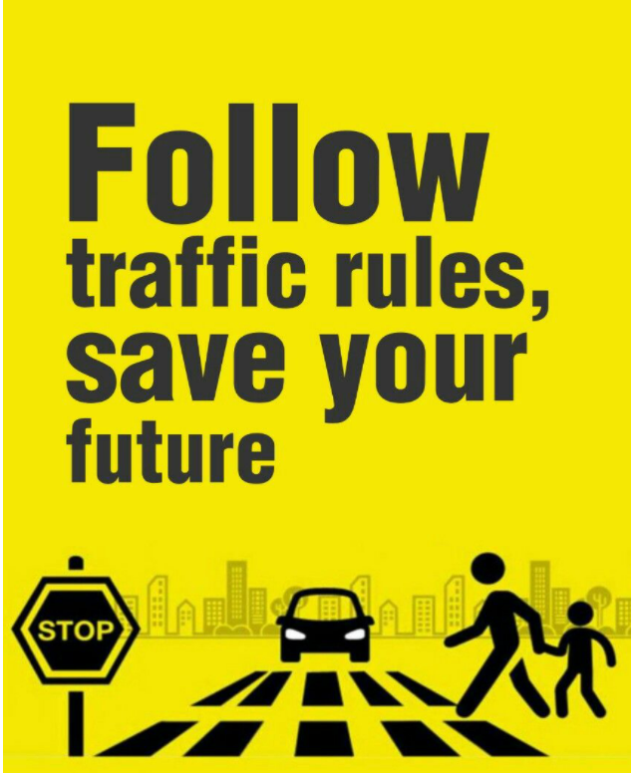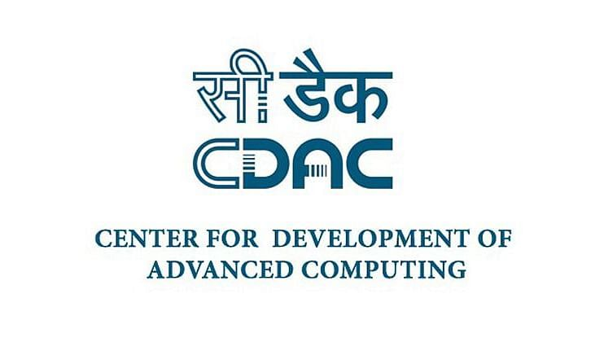

**TRAFFIC RULE REMINDER**

Presented By:

1. Mayuri Mahadik (06)
2. Nikhil Kundgar (32)
3. Pritesh Suryawanshi (37)
4. Shubham Raghawant (56)

|  |
| --- |
| **Abstract** |
|  |
| India is a country with the second largest road network in the world. Out of the total strength of 5.4 million Km of road network, almost 97.991 Km is covered by the national highways.According to the survey, the total number of vehicles in year 2019 stood at 295.8 million. The road travel seemed to be the preferred choice in India with over 60% of population who use the personal vehicles.Traffic e-challan fines of more than Rs 700 crore are unpaid across Maharashtra till date, said state transport commissioner Avinash Dhakane. And of this, traffic violators in Mumbai owe the traffic police almost Rs. 280 crores, nearly 40%It is generally observed that traffic rules are not followed seriously and even when challans are fined against the violations they are not paid on time and are ignored. In order to overcome this problem, we are introducing a model: **TRAFFIC RULE REMINDER**(**TRR**) which will make the vehicle user to obey traffic rules and regulations. |

India is home to 22 cars for every 1000 individuals (source). Although this ratio is just a fraction of the figure in countries like the USA and UK, it still represents a massive number of vehicles, considering India’s population.

With so much traffic on the country’s roads, the traffic authorities often face immense difficulties in maintaining law and order.

Many new drivers tend to be unaware of these rules, while others simply violate the laws without thinking about the safety of others. If you are planning to start driving in a few days, here are some of the basic rules that you must know of, along with the repercussions of disobeying them.

Basic Traffic Rules and Regulations of India

1. Do not Drink and Drive
2. Always own Valid Vehicle insurance policy
3. Riding triple seat on a bike.
4. Riding two-wheeler without a helmet on
5. Using Mobile Phones while riding
6. Over Speeding
7. Jumping the Red Light
8. Fancy Numberplate and Filming
9. Illegal modification with loud silencers
10. Vehicle should stop before zebra crossing.

TRAFFIC RULE REMINDER is a software application which forces vehicle user to follow the traffic rules sincerely. This application includes

* All the traffic rules along with the charges for the violation.
* Information about vehicles and the owner’s details, violations which are caused with their vehicles.
* Record of all the violations caused.
* Actions taken after the violation takes place.

|  |
| --- |
| Introduction |
|  |

|  |
| --- |
|  |

**Problem Statement:**

Implementation of Software technology which will increase the number of people who obey Traffic Rules sincerely. Although Indian Government has made several traffic rules and regulations; still there is rise in dis-obeying and breaking traffic rules buy user.

**Requirements:**

* Data entry from the traffic officer regarding the violation.
* Vehicle information based on their registration. Also, information about the vehicle owner.
* Fast tag details of the vehicle.
* Traffic rules information.

**Software specification:**

1. Java
2. MySQL

**Project Scope:**

The main purpose of the project is to implement traffic rules strictly and make people aware about them. This will also help in reducing the non-essential conflicts faced by the traffic officers. When the rules are followed sincerely, there will be less accidents caused on the roads.